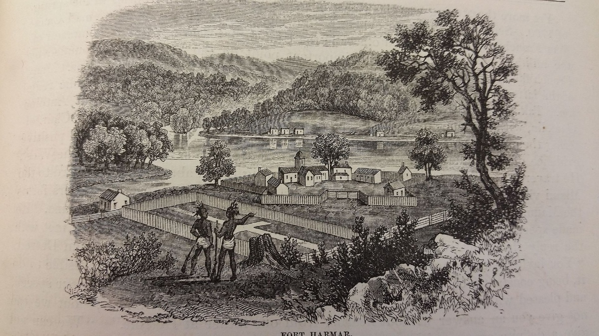

FORT HARMAR 240th ANNIVERSARY PROGRAM
100 FORT SQUARE, MARIETTA, OHIO 45750
November 5, 2025 at 10:00am

November 5th 1785, the US Army First American Regiment arrives to construct Fort Harmar.

The public is invited to attend and celebrate the 240th Anniversary at the Fort Harmar Monument next to Harmar School. Join us as the Marietta Chapter Sons of the American Revolution Color Guard will present the Colors, wearing the uniform of those soldiers of 240 years ago. Historian Scott Britton will share stories of the frontier fort. We will have a special WMOA radio recording from their Pioneer City Past series with the late Louise Zimmer.

Told as only Louise could, the recording recounts the pageantry of Captain David Ziegler’s company of 55 sharpshooters, escorting Chief Cornplanter’s contingent from the Senaca Nation “in full ceremonial dress”, arriving for treaty talks at Fort Harmar.

Refreshments at the Fearing House Museum following the program. In case of bad weather, the program will be held at the Fearing House, 131 Gilman Street, Marietta.

Research Fort Harmar at https://www.mariettasar.com/fort-harmar

U. S. Army History:
The First American Regiment of The United States was the first peacetime regular infantry unit authorized by the Confederation Congress after the American Revolutionary War. Organized in August 1784 at an authorized strength of 700 soldiers, it served primarily on the early American frontier west of the Appalachian Mountains. On November 5th 1785, 150 of these soldiers arrived at the confluence of the Ohio and Muskingum Rivers to establish Fort Harmar. Their task was to drive off squatters, restore order, and lead America’s effort to establish new governance in the Northwest Territory.

For information, mariettasar.com or contact Secretary Jean Yost at 740-336-8060 or jean.yost@gmail.com.

