U.S. Marine Corps 250th Anniversary
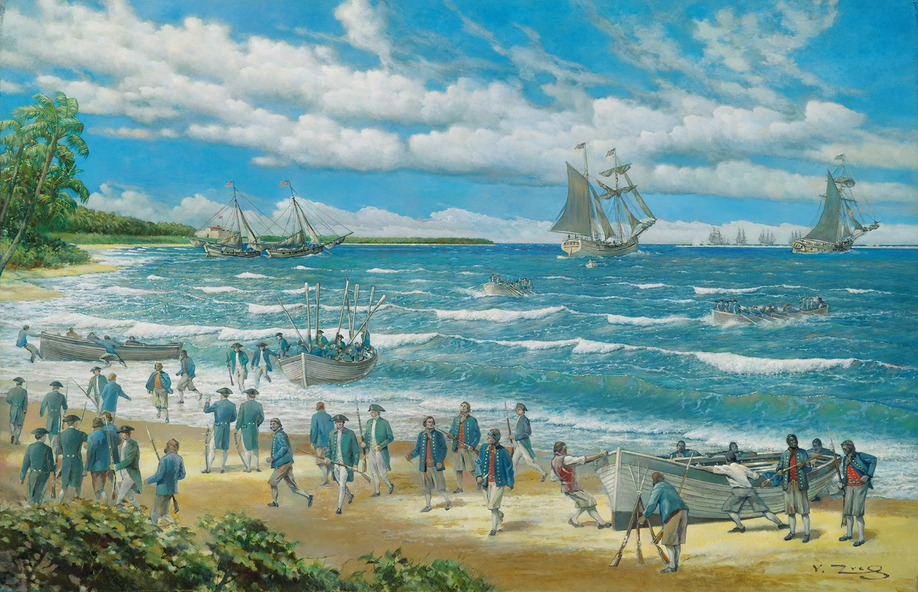
Marietta to Host County-Wide Celebration
of U.S. Marine Corps' 250th Anniversary

MARIETTA, OH – The Marietta Chapters: Sons of the American Revolution (SAR) and Daughters of the American Revolution (DAR), in partnership with Veritas Classical Academy, invites the public to a special ceremony commemorating the 250th Anniversary of the United States Marine Corps. The event will take place on Monday, November 10, 2025, at 10:00 AM on the Veritas Classical Academy campus, 115 Victory Place.

This milestone celebration will honor the history and legacy of the U.S. Marine Corps, founded on November 10, 1775. The program will feature guest speakers, patriotic musical performances, and participation from Marine veterans, descendants of patriots, and local students. A special focus will be placed on local Washington County residents who have served in and commanded the Marine Corps throughout its history.

The community is encouraged to attend this free event to show appreciation for the service and sacrifice of Marines past and present.

For more information, please contact Jean Yost, 740-336-8060, jean.yost@gmail.com or mariettasar.com

